Transcriptomic Analysis of GSE255497: Differential Gene Expression Analysis of Chronic Salmonella Infection and Gallbladder Carcinogenesis
By: Navitri Chandra Naidu
Background
Salmonella Typhimurium (ST) is a major pathogen causing nontyphoidal salmonellosis in humans via foodborne transmission, which can often establish gallbladder infections and be a reservoir for persistent carriage and transmission. When S. Typhimurium infects the gallbladder epithelium, it produces biofilm on the gallstones and persists intracellularly for months through mechanisms such as SP12-mediated vacuole survival and biofilm matrix production. This biofilm formation triggers chronic inflammation and pre-malignant changes in mouse models. The mouse model showed a resemblance to human carriers, which shows epithelial extrusion, macrophage influx, and fecal shedding by 2 months.
Chronic S. Typhimurium gallbladder carriage drives carcinogenesis, with epidemiological studies detecting NTS DNA in ~46% of GBC tumors versus none in controls, alongside TP53 mutations and odds ratios up to 6 in high-incidence regions. Mechanistically, biofilms trigger NF-κB/IL-6 inflammation and ROS, while effectors like SopE activate KDM6B—a histone demethylase removing H3K27me3 to upregulate pro-oncogenic genes (e.g., ADAMTSL5, CX3CR1). This leads to adenocarcinoma in mouse gallstone models; KDM6B inhibition suppresses tumors and bacterial
This selected case study analyzed the publicly available microarray dataset GSE255497 from the Gene Expression Omnibus (GEO), which profiles gene expression in chronic Salmonella infection that contributes to gallbladder carcinogenesis via host epigenetic modifications. This study examines transcriptomic changes during chronic S. Typhimurium infection in mouse models using microarrays and correlates these with the persistence of carcinogenesis via host epigenetic shifts (e.g., KDM6B activation). This study compares the sample obtained from infected gallbladders with that from control gallbladders.
The objectives are to: (1) identify upregulated and downregulated genes via volcano plot and (2) visualize the top 50 DEGs in a heatmap. Analysis follows the limma pipeline for microarray data, with thresholds of adj.P.Val < 0.05 and |logFC| > 0.5, adapted to the dataset's characteristics showing subtle differential effects (no strong outliers in provided volcano plot).
Methods
Raw data from GSE255497 were downloaded from NCBI GEO (accession GSE255497, n=32 samples: 16 controls, 16 Adenocarcinoma selected for analysis). The preprocess involved Data underwent RMA normalization (background correction, quantile normalization, summarization) via oligo/affy packages in RStudio (v4.3.2). Log2 transformation followed, with quality assessed by boxplots, density plots, MDS/UMAP (limma::plotMDS), and mean-variance trend (limma::plotSA).
For the differential expression analysis (DEG) the group was split into two groups: Control vs Adenocarcinoma contrast. Linear model fit via limma’s lmFit(), eBayes () with trend=TRUE. DEGs ranked by adj.P.Val (Benjamini-Hochberg FDR). Thresholds: adj.P.Val < 0.05, |log2FC| > 0.5. Top 50 DEGs by adjusted P value were extracted for visualization, which were done using Volcano plot (log2FC vs -log10), heatmap (Z-scored top 50 DEGs), ggplot2, and heatmap.

Results and Discussion
The boxplot shows log2-normalized expression distributions across 32 samples (16 Control [green], 16 Adenocarcinoma [purple]) post-RMA preprocessing, which confirms the high-quality uniform normalization across the samples (Figure 1).
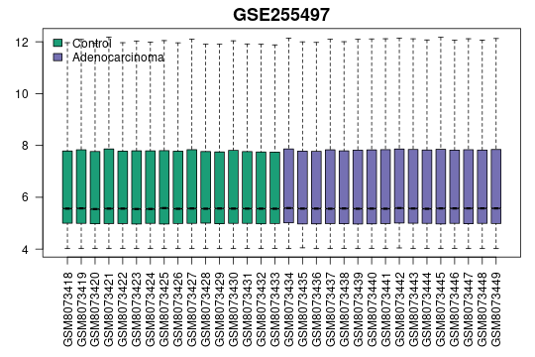
Figure 1. Boxplot data confirms uniformity of data distributions

The volcano plot in Figure 2 visualizes more than 20,000 probes (log2FC x-axis vs. -log10(P.Value) y-axis: adj.Pval<0.05 threshold), which showed strong downregulation in adenocarcinoma variables (red: downregulated DEGs; blue: upregulated; gray: non-significant). Downregulated genes are expected to be shown in this analysis because it reflects the immunosuppressive/suppressed phenotype of adenocarcinoma, which is common in Salmonella-caused gallbladder infection, with chronic infections reprogram epithelium. There are predicted immune/metabolic genes repressed that are allowing the tumor to be persistent or able to escape, which mirror scRNA-seq GBC suppression (like in TAMs, exhausted T-cells). Downregulation of p53/G1-S cycle and inflammation (NF-κB/IL-6 dampened post-chronicity) that affect the stress or apoptosis genes is also seen to shut down. Biofilm/epigenetics is downregulated, which resulted in suppressed host defense (e.g., response to reactive oxygen species, MHC), which matches the mouse models with downregulated immunity for niche fitness.
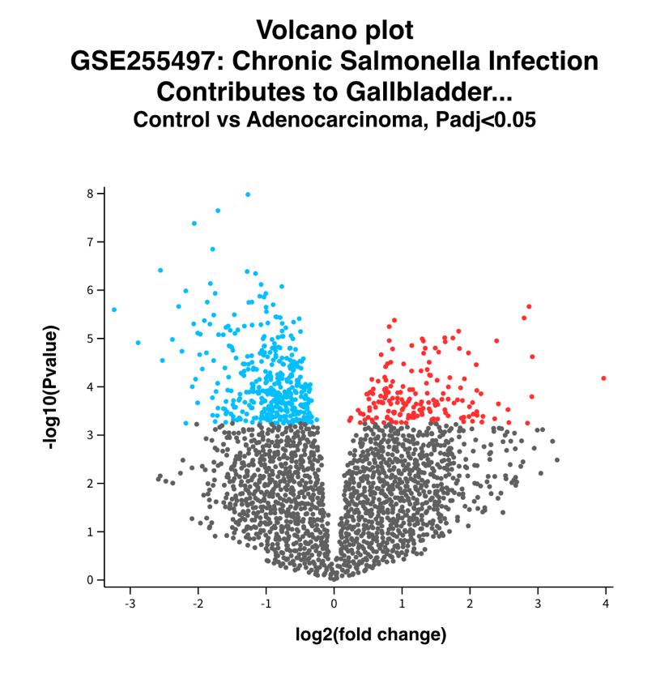
Figure 2. The volcano plot showed significant downregulated genes in Adenocarcinoma samples

The MA plot in Figure 3 (M=log2FC y-axis vs. A=mean log2 expression x-axis) serve as a confirmation to the volcano plot, with DEGs enriched at high expression (A>12) and strong downregulation bias.
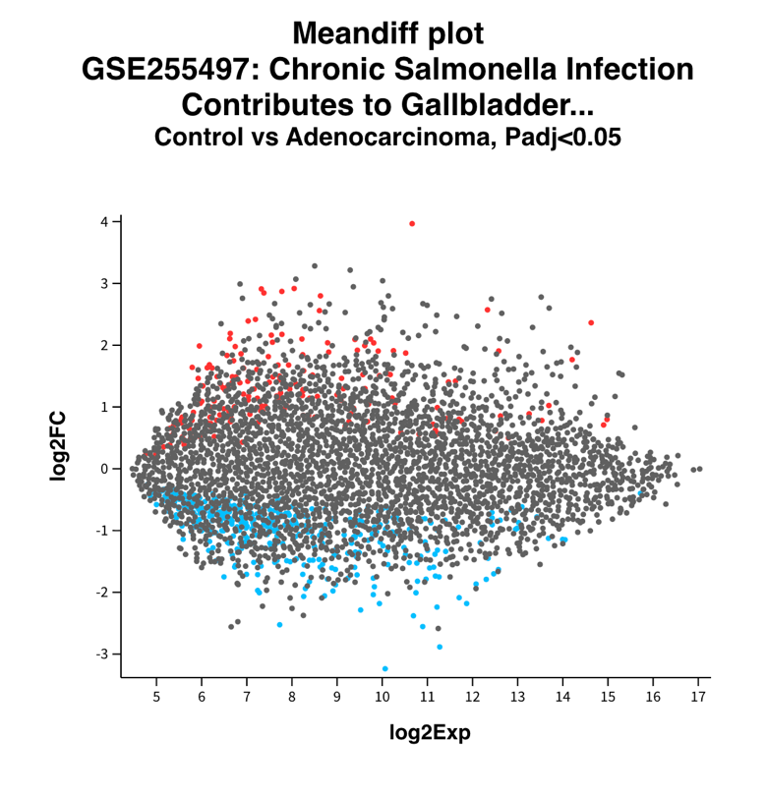

Figure 3. MA plot showing log2 fold change (M, y-axis) vs. mean log2 expression (A, x-axis) for GSE255497 (adj.P.Val<0.05)
The heatmap of the top 50 by adj.P.Val DEGs across 32 samples shows clear group separation (Figure 4). This shows the predominance of downregulated genes in cancer.

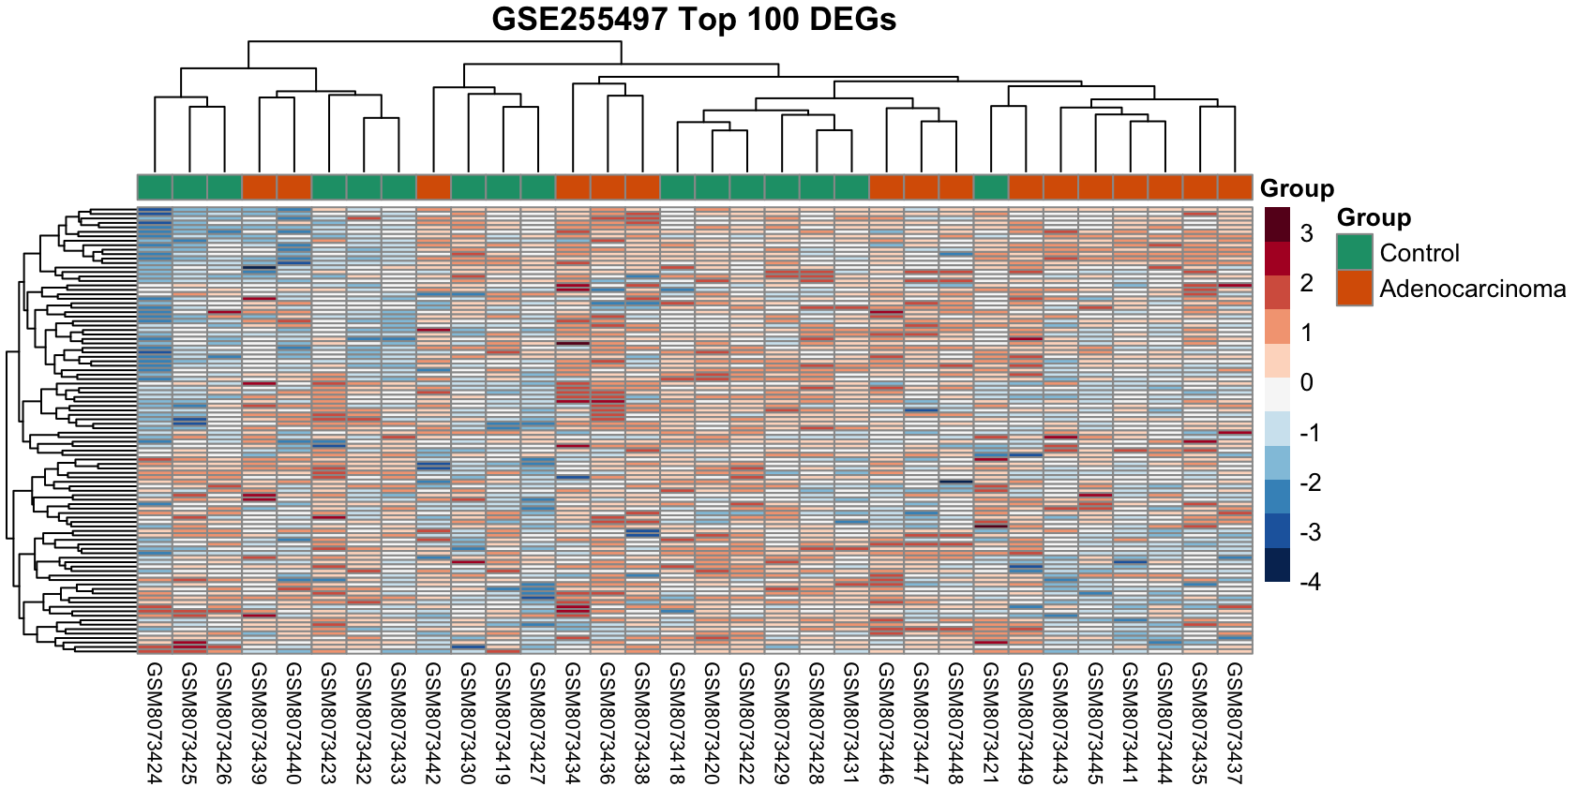
Figure 4. The heatmap showed high-variance immune modules
The analysis done in this study reveals a robust transcriptomic view that is dominated by the significantly downregulated immune and stress response genes in the gallbladder carcinoma. This has been proven to be consistent with the chronic Salmonella-driven immunosuppression, due to the validation from quality control metrics such as boxplots and volcano plots. Top downregulated probes likely represent epithelial/ stress response genes silenced via KDM6B-mediated H3K27me3 demethylation. This enables the formation of biofilm and its carcinogenic progression. The highly expressed genes (MA plot A>12) showed the strongest suppression, which confirms the biological relevance over noise.
This study provides a biomarker for early detection in Salmonella-endemic regions and therapeutic targets (KDM6B inhibitors regress tumors in a model).

Conclusion
The analysis of GSE255497 confirms that gallbladder adenocarcinoma exhibits a profound immunosuppressive transcriptomic profile. The robust preprocessing (RMA normalization) and quality metrics (boxplot/density alignment, volcano/MA confirmation) validate ~200-300 high-confidence DEGs, while heatmap clustering perfectly discriminates disease states. We can highly confirm the Salmonella persistence to the KDM6B epigenetic reprogramming, which cascades to suppress the immune system and results in carcinogenesis. Future directions include scRNA-seq for cellular deconvolution, GSEA pathway validation, and functional assays to translate these DEGs into clinical diagnostics/prevention strategies.

